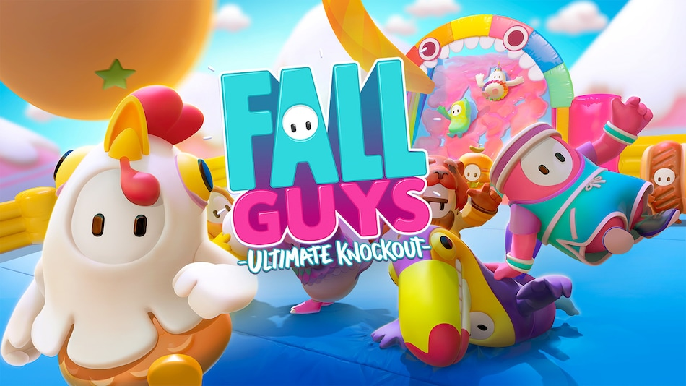

**Fall Guys**

**Developed By:** [Mediatonic](https://www.google.com/search?sxsrf=AOaemvJRlZmxLs5U3w9X6Shw0i6_drgr4g:1639576392490&q=Mediatonic&stick=H4sIAAAAAAAAAOPgE-LVT9c3NMyozMouqMqyVOLSz9U3KK-oMEsy0lLJTrbSTy5L10_Ozy0oLUktii_LTEnNT0_MTbVKSS1LzckvSC1axMrlm5qSmViSn5eZvIOVEQBok_S1UwAAAA&sa=X&ved=2ahUKEwiN6dKD-uX0AhWlNOwKHdIrC1EQmxMoAXoECDwQAw)

**Description:** Fall Guys: Ultimate Knockout is a platform battle royale game developed by Mediatonic. Up to 60 players control jellybean-like creatures and compete against each other in a series of challenges, such as obstacle courses or tag.

**Platforms:** PlayStation 4, Xbox One, Xbox Series X and Series S, Android, Nintendo Switch, Microsoft Windows, iOS.

**System Requirement:**

* A minimum computer system that will help you access all function in the game is a Pentium 166 or better.
* 64 Megabytes of RAM or better.

**Published By:**

